Tuesday 7th January 2025
Good morning, Year 1
Here are some activities for you to have a go at today.
Phonics | Can you practise the split digraphs that we have been learning last half term? Sound them aloud and write them down.  wave joke line rule shade alone inside
English | In English, the book we will be reading will introduce an emperor penguin. Can you use the link to discover information about emperor penguins? Then, can you write 3 sentences with some facts about them? Challenge yourself to use the words ‘and’ or ‘because’ in your sentences.  Emperor Penguins - BBC Teach
Maths | 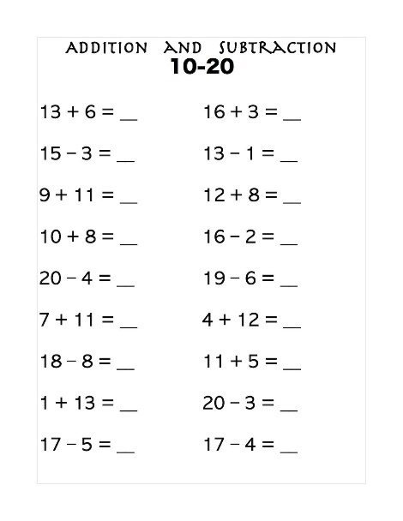  Can you write these out in your homework books or on paper and have a go at working out the answers?
Computing | We are going to become Maze Explorers in our Computing lessons this half term. Please check your 2dos on Purple Mash (guiding the fish to the treasure chest). Your password and username is in your reading record.
Art | We are going to be learning about the artist Steven Brown. Here is a piece of his work.  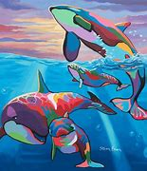  Can you have a go at drawing this? You could add some colour to it using whatever equipment you have at home.
Reading | Please read some of your Little Wandle book or your reading for pleasure book, with your grown up, and see if you can answer questions about what you have read.

