Canopus Class
Remote Learning Monday 6th January 2025
English  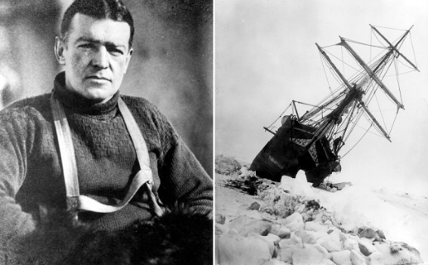 | We are going to be reading ‘Shackleton’s Journey’ which is about Ernest Shackleton’s journey to the Antarctic onboard The Endurance. Look at https://www.bbc.co.uk/bitesize/articles/z7xnn9q or https://kids.britannica.com/kids/article/Ernest-Henry-Shackleton/598856 to learn some exciting facts about Shackleton’s life. Write down key facts about Shackleton’s life.
Maths   | In Maths we are starting our new Multiplication and Division unit of work. Ready for using efficient methods this week, please practice your times tables either on TTRockstars or https://www.timestables.co.uk/games/ or https://www.multiplication.com/games/multiplication-games
Design Technology  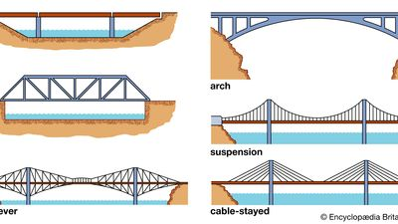 | We are going to be researching different types of bridges. Please watch https://www.youtube.com/watch?v=oVOnRPefcno to introduce the different types of bridge. Next read some of https://kids.kiddle.co/Bridge and choose your TOP 3 FACTS to write down to share in class this week. If you have paper and a ruler, you could draw your favourite type of bridge too.
Computing   | Please log in to Purple Mash www.purplemash.com (your log in details are in your Reading Record). There are To-dos set for today for our new Coding unit of work. The work includes a Coding Quiz and a Free Coding Gibbon activity.

