Monday 6th January 2025

Good morning Year 1 and a very Happy New Year to you! We hope you have all had a wonderful Christmas holiday. We are looking forward to seeing you all and can’t wait to hear all about it.

Here are some activities for you to have a go at today in preparation for this term. 😊

|  |  |
| --- | --- |
| Phonics | Please see the tricky words below. Can you read them? Now, can you have a go at writing them? You could do ‘Look, cover, write and check’. |
| English | We are going to be a starting a new book called The Emperor’s Egg. This is set in Antarctica. Look at the picture below to see if you can gather some adjectives (describing words) to describe the setting. Then, can you write some sentences to describe it too?  Ideas – freezing, icy and chilly. |
| Maths | We are going to be doing lots of work with numbers up to 20. Look at the numbers below and practise reading and writing the numerals and words. If you want to challenge yourself, see if you can add and subtract numbers to 20. |
| PE | Create your own fitness circuit (5 of each movement) and tell us how you got on. You could include, as an example – star jumps, tuck jumps and jogging on the spot. We hope you can also enjoy some fresh air outdoors today if it is safe to do so. |
| Geography | Our Geography links to our English as we are exploring polar regions. Look at the picture below. Imagine you are going on an adventure here. Think about what you will need to pack in your suitcase and what you might see when you get there! Can you write two sentences to tell us? You could also include a picture! |

**Phonics – tricky words:**

said come what

have little when

like one out

so were

do there

**English – Antarctica:**

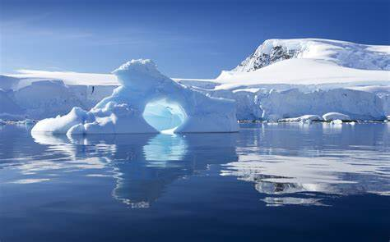

**Maths – numbers to 20:**

|  |  |  |  |
| --- | --- | --- | --- |
| 1 one | 6 six | 11 eleven | 16 sixteen |
| 2 two | 7 seven | 12 twelve | 17 seventeen |
| 3 three | 8 eight | 13 thirteen | 18 eighteen |
| 4 four | 9 nine | 14 fourteen | 19 nineteen |
| 5 five | 10 ten | 15 fifteen | 20 twenty |

**Geography – Polar regions:**

