Canopus Class
Remote Learning Tuesday 7th January 2025
English  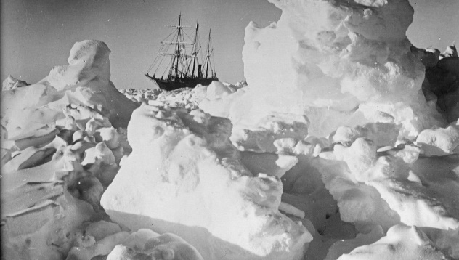 | Following on from yesterday’s introduction to Shackleton’s polar journey, today please imagine you are on your own polar journey. Write a diary in role as an Antarctic explorer. You should describe the cold, icy conditions, what equipment you have needed, any problems you may have had and how it has made you feel.  Features of a diary can be found here… https://www.bbc.co.uk/bitesize/articles/z4qtqfr
Maths   | In Maths we are starting our new Multiplication and Division unit of work. Please continue to practice your times tables either on TTRockstars or https://www.timestables.co.uk/games/ or https://www.multiplication.com/games/multiplication-games
Violins  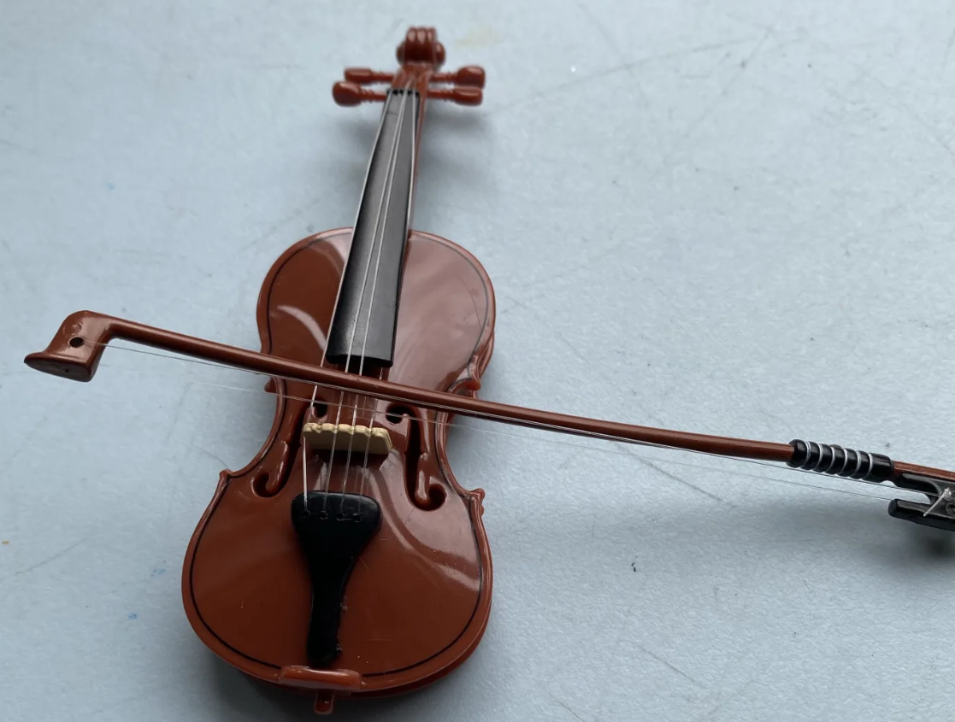 | Since you cannot practice the violin at home, please find out some interesting facts about the violin here: https://getkidsintomusic.com/2023/02/20/facts-about-the-violin/ You could make an information leaflet or poster to share your information on Purple Mash.
Religious Education   | Find out about the 5 Pillars of Islam by watching this short video: https://www.bbc.co.uk/teach/school-radio/articles/zvvvp4j  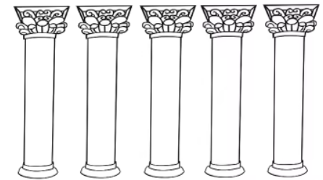  Create your own 5 pillars sheet to label and add information to. Try to use a ruler for your pillars.

