**English**

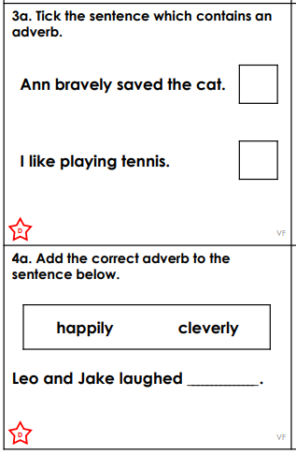We know that a verb is a doing word. We also know that an adverb describes the verb in more detail. Therefore, have a go at these questions!

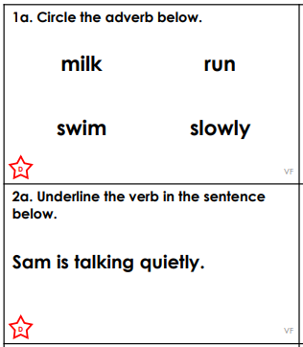

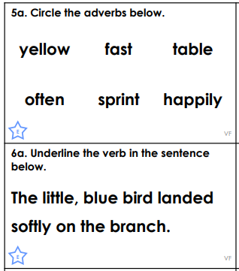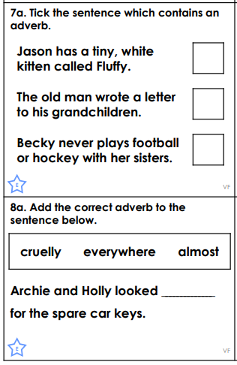

**Maths**

Today, I’d like you to have a go at multiplying by 10 and 100. When we multiply by 10, the numbers move one space to the left and we add in a placeholder (a zero). When we multiply by 100, the numbers move two places to the left and we add in two placeholders (two zeros). Have a go and we will practise more at school when we are back!

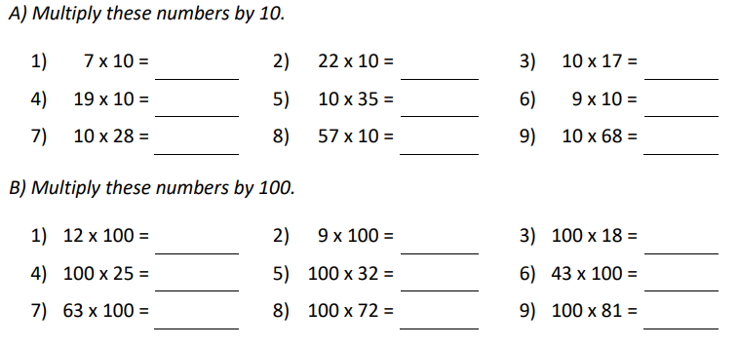

**Scienc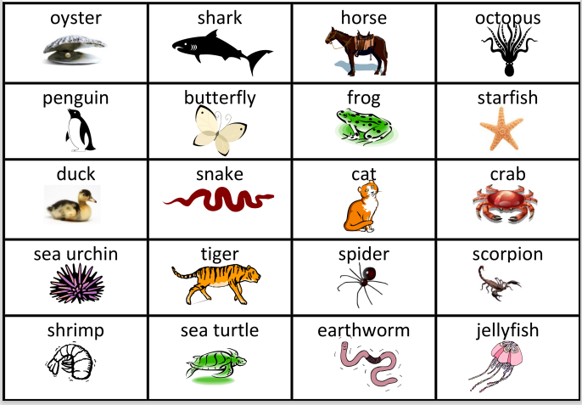e**

In Science, we are focussing on Living Things and their Habitats. We can group living things together in lots of different ways. The first groups we can use are vertebrates or invertebrates. A vertebrate has a backbone whereas an invertebrate doesn’t have a backbone. Have a go at sorting these living things into vertebrates and invertebrates.

You could use a table like this:

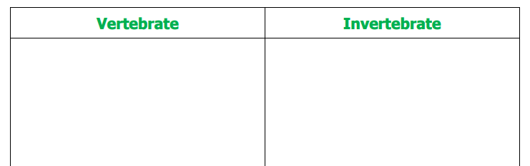

**DT**

In DT, we are going to be designing and making our own slingshot car! Think about these questions:

* What are cars for?
* Why are they so popular?
* What was the earliest form of the car?
* How might your life change if they didn’t exist?
* Can you identify any types of mechanisms that you know of in a car?
* How are cars fuelled?
* Can you think of more eco-friendly alternatives?

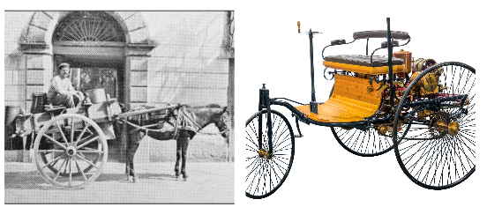

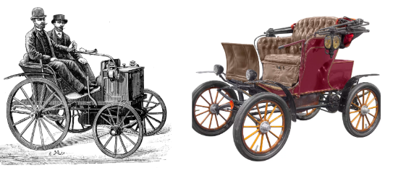

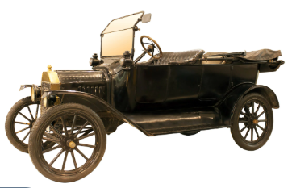 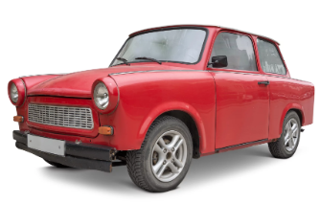

Using the images, think about how cars have developed over time. Are there any similarities? Are there any differences?