**English**

Write a short diary entry for one of your days in the holiday. Challenge yourself to include a fronted adverbial followed by a comma. Here are a few examples:

* In the morning,
* At lunchtime,
* At 5pm,

**Maths**

We are looking more closely at multiplication and division and written methods we can use to help us work out answers. Therefore, spend some time on ttrockstars to practise your timestables. Alternatively, have a go at these timestables!

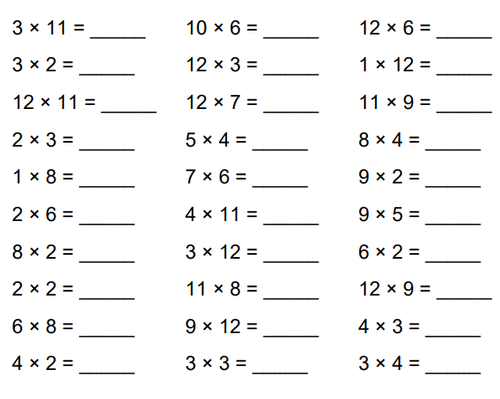

**Computing**

It is extremely important to recap online safety so there is a 2do set for you all about online safety. Your job is to create an online safety poster thinking about rules which will help keep you and others safe online. Have a look at the hints and prompts down the side to help you! Alternatively, create a poster on a piece of paper!

**PE**

Try to do something active for at least 30 minutes! This could be a Joe Wicks activity on Youtube. It could also be Danny Go videos, Cosmic Kids Yoga videos or even creating a dance to a song which you can show us in our next lesson.

Don’t forget to read!